# Onion Architecture:

<https://www.codeguru.com/csharp/understanding-onion-architecture/>

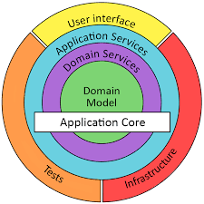

# Clean Architecture:

<https://www.freecodecamp.org/news/a-quick-introduction-to-clean-architecture-990c014448d2/>

<https://www.c-sharpcorner.com/article/clean-architecture-in-asp-net-core-web-api/>

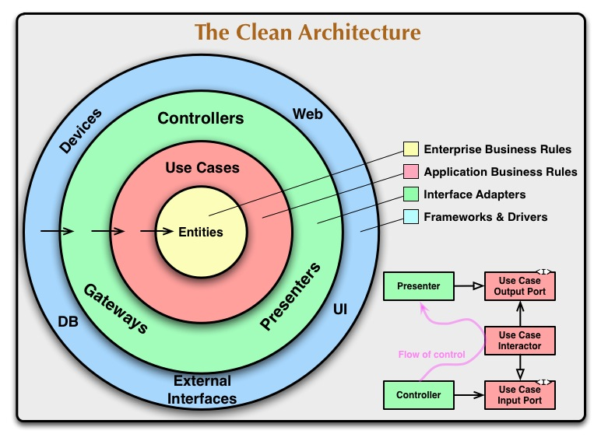

# What is Software Architecture?

It is way to design the structure/building-blocks of software based on certain attributes and requirement (technical and operational requirements) given.

It describes major components, their relationships (structures), and how they interact with each other.

<https://www.tutorialspoint.com/software_architecture_design/introduction.htm>

**Software Architecture attributes:**

**Types of Software Architecture:**